**Regency Style Gold Decorated Beveled Glass Mirror**

**Price: $500**

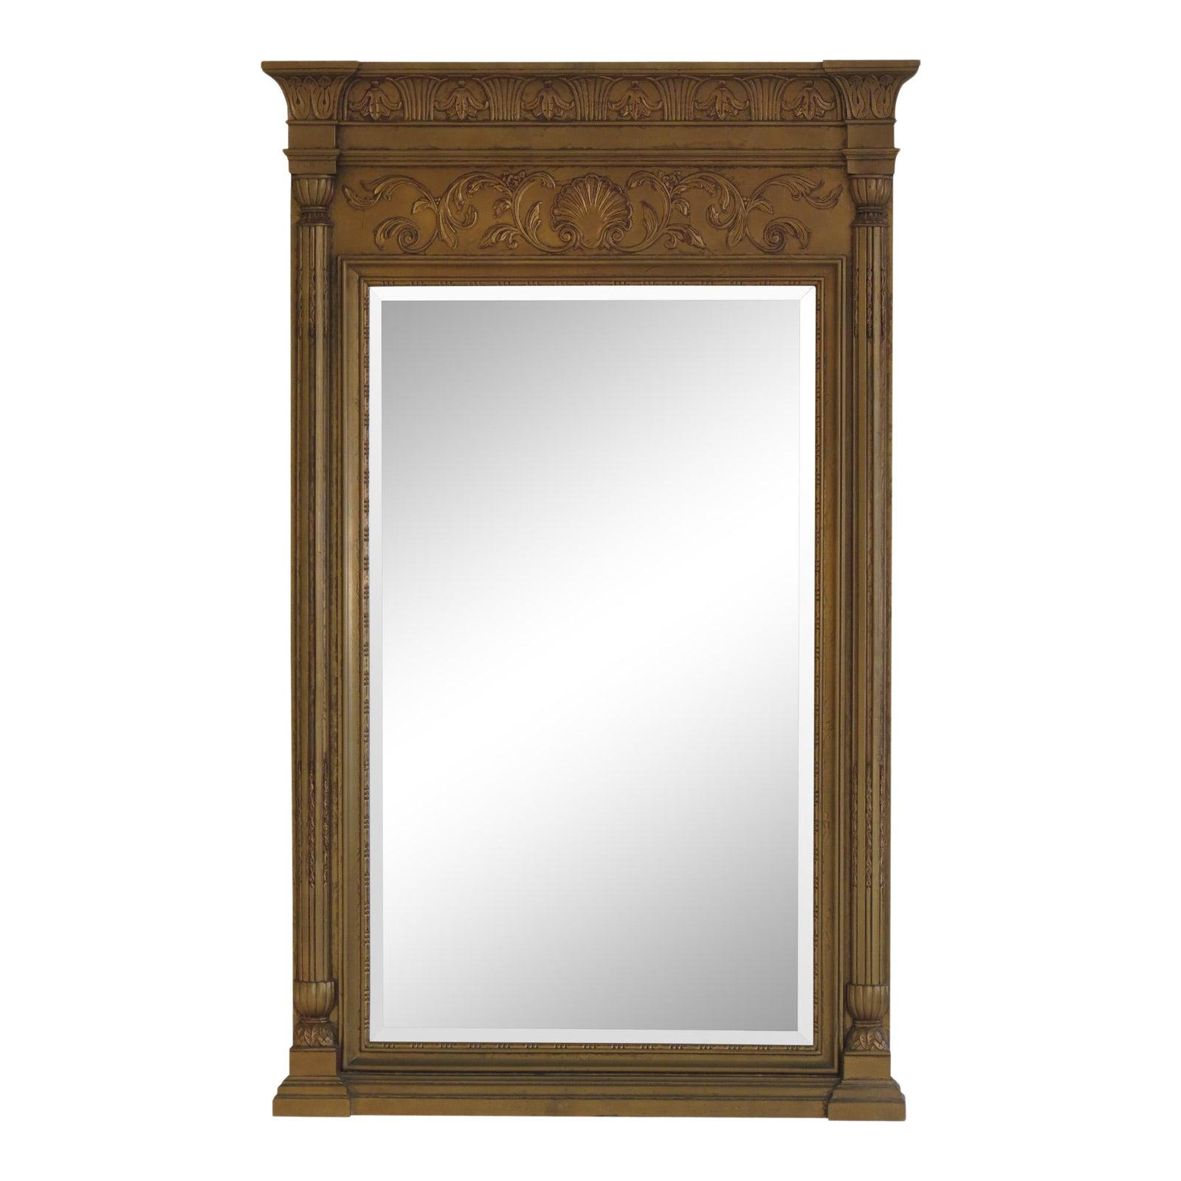

* CATEGORIES

Drawing/Living room mirrors

* MATERIALS

Acrylic Bordered

* SHAPE

Rectangle

* BRAND

Viglacera